NAME  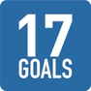 | NAME | NAME
NAME | NAME | NAME
NAME | NAME | NAME
NAME | NAME | NAME
NAME | NAME | NAME
NAME | NAME | NAME
NAME | NAME | NAME
NAME | NAME | NAME

